Section 7: Rocket Ships

NOTE: As explained in the Foreword, this supplement is intended to be comprehensive but not all inclusive, so in some cases if more in-depth information is desired you will need to read through the necessary book or books. So with this in mind this section is intended only as an introduction into an important aspect of the BR XXVc game, rocket ships.

Rocket Ships
A 25th Century rocket ship is an advanced and highly sophisticated piece of machinery. Yet, in basic principles, it is almost exactly like the ancient rockets of the 20th Century; a hollow tube containing fuel, an electronic guidance system, and an engine pushing fire out of the back. Actually, there is a little more to it then that. The internal systems of a typical rocket include the following components.
Sensors: Sensors tell the rocket where it is going and what it is encountering along the way. The communication system, which is combined with the sensors, enables a ship to send and receive messages. There are three “sensor module bundles” available.
- Commercial: The Commercial Bundle is available on most commercial and civilian ships. The bundle contains the following sensors; Radiation Sensor, Spectrographic Sensor, Radio Sweeping Sensor, Infrared Pattern Sensor, Friend-Or-Foe Sensor, and Visual Spectrum/Ultraviolet Sensor.
- Military: The Military Bundle is available on must warships and custom paramilitary ships. The bundle contains all the sensors listed in the Commercial Bundle, plus the following new sensors; Radar Sensor, and Combat Tactical Sensor.
- Scientific: The Scientific, or Optional, Bundle is not at all common and if found is usually found on highly customized ships. The bundle contains all the sensors listed in the Military Bundle, plus the following new sensors; Particulate Sensor and Infrared Sensor.
Controls: Controls are used to steer and propel the ship.
Life Support: Life Support includes air tanks, air and water recyclers, hydroponics vats, and air-conditioning systems.
Fuel: Fuel is a mixture of the raw chemicals burned by the engine, as well as refrigeration units to keep the fuel and oxidizing agent at extremely cold temperatures, and pumps to move the fuel into the engine when it is needed.
Engine: The Engine is one word that covers a lot of smaller devices and subsystems. The Injector mixes the fuel and pumps it into the Reactor, which then superheats it into a gas (shielding around the reactor keeps the radiation from reaching the crew). Finally, the Fusion Converter (not found on some ships) bombards the superheated fuel with free electrons, turning it into pure fusion energy.
25th Century rockets take off and land vertically. Powerful gyrostabilizers keep the rocket balanced on its fins as it comes in for a landing, while massive jacks make sure it cannot be toppled while it is sitting on the ground. The rocket is arranged in a series of decks, stacked one on top of the other, with the sides of the rocket serving as the walls and the intervening decks as floor and ceilings. This means that to go from one part of the rocket to another requires elevators of ladders.
When the ship is on the ground, the force of gravity holds things down to the decks. When the rocket is moving, the constant push of the engines provides a counterforce that pushes objects to the “back” of the rocket, providing a sort of artificial gravity. When the engines cut off, this effect of acceleration disappears and everything in the rocket becomes suspended in zero-g.
In the early days of interplanetary travel, ships blasted nose first for half of a trip, then turned end over end and blasted in reverse to slow down for landing. Modern ships are far more powerful then those older ships, and are able to make the braking maneuver at the last part of the trip, just before landing. Braking uses a great deal of power and fuel, but these are two things ships have a lost of.

Types of Ships/C&C Pg.74
So far we have talked about the basic mechanics of rockets. In the descriptions below you will learn about some of the types of ships available.

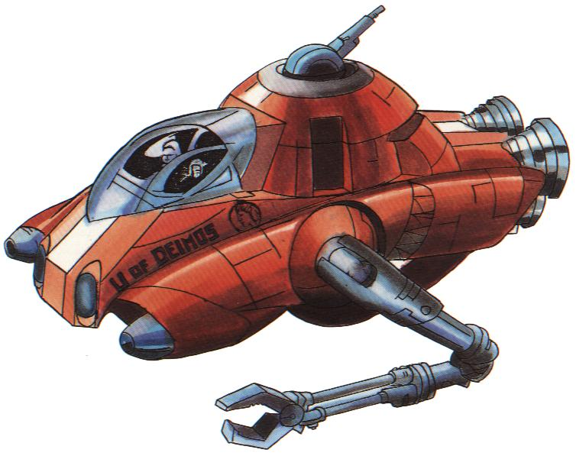

Asterovers: The asterover is an all-purpose vehicle very popular in The Belt. It contains a powerful rocket motor, a bulky cockpit, some lab and living space, and stubby maneuvering fins. It is a purely brute-force vehicle, able to travel from orbit to planet surface and back again, however, it is not capable of interplanetary flight.

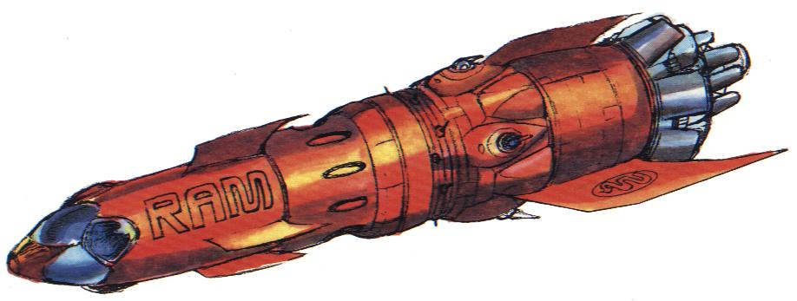

Battlers: These are by far the largest ships in the solar system, ranging in length from 2000 to 10,000 feet (nearly 2 miles). Each one is essentially a space faring military base, carrying enough weaponry and enough troops to mount a successful full-scale assault on most medium sized cities. Because of their size battlers can carry other ships; many battlers have hanger bays for fighters. They are deep space vessels, unable to land on planets. However, they must sometimes skim the atmosphere of a planet to scoop up gases, so they are moderately streamlined, built around a cylindrical hull with a cone shaped nose

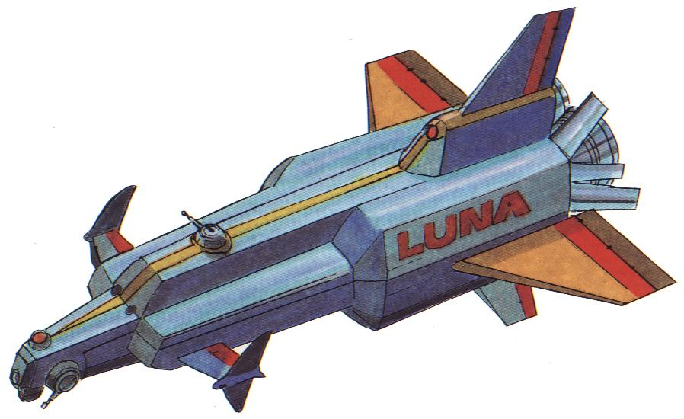

Cruisers: Cruisers are the main vessels of the solar system. Unlike fighters cruisers are capable of moving in all mediums. Most cruisers range from 50 to 200 feet in length, although, some heavy cruisers are as long as 1000 feet. The hull is cylindrical and vanes or wings are often mounted on the hull for stabilization in the atmosphere, however, they do not use the wings for flight, they use their huge rocket motors to “brute force” their way through. Because of their size and powerful Fusion Converters, they are the most commonly used ships for interplanetary travel and can be used in a wide variety of situations.
- Scout Cruisers: Ranging from 40 to 100 feet long. They are almost as fast and maneuverable as fighters, and can often hold their own in a dogfight.
- Medium Cruisers: These cruisers, ranging from 110 to 400 feet long, are the mainstay of any fleet. They are well armed and versatile.
- Heavy Cruisers: These large warships, ranging from 410 to 1000 feet long, are very powerful and are able to engage most opponents, dish out incredible damage, take a lot of punishment, and still be victorious.

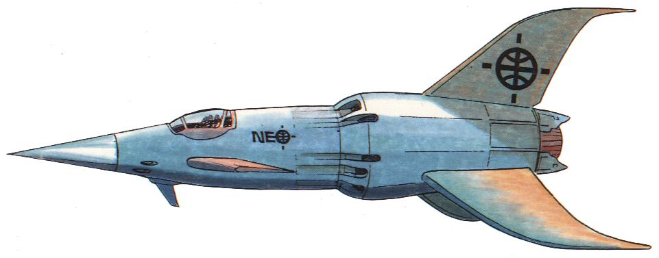

Fighters: Fighters occupy a very specific niche in the forces of the solar system – they are the supreme combat machine, faster and more maneuverable then any of the larger classes. They are normally very small, one to two-man ships, with limited range and weaponry. They are powered by less sophisticated engines that lack the Fusion Converters, making them incapable of interplanetary travel, however, they can be carried from place to place as part of a larger ships cargo load. The biggest strength of the fighter is its ability to be designed for specific environments. But as a result of this specialization, fighters are generally limited to being usable on or near the planet for which they were designed or are restricted from the atmosphere if designed solely for use in space.
- Earth Atmospheric Fighters: These types are a mix of streamlined hulls and narrow, variable wing geometry; in some ways they resemble the sleek fighter planes of the late 20th Century.
- Martian Atmospheric Fighters: These types have large wings for better maneuvering in the thin Martian atmosphere. They are armored with an ablative plastic hull coat which resists sandstorm damage.
- Venusian Atmospheric Fighters: These ugly fighters are adapted for the harsh acid rains and heavy atmospheric pressure of Venus. As a result, they are more like dirigibles then airplanes, with sturdy hulls and ballast tanks. They do not fly as much as swim through the dense air.

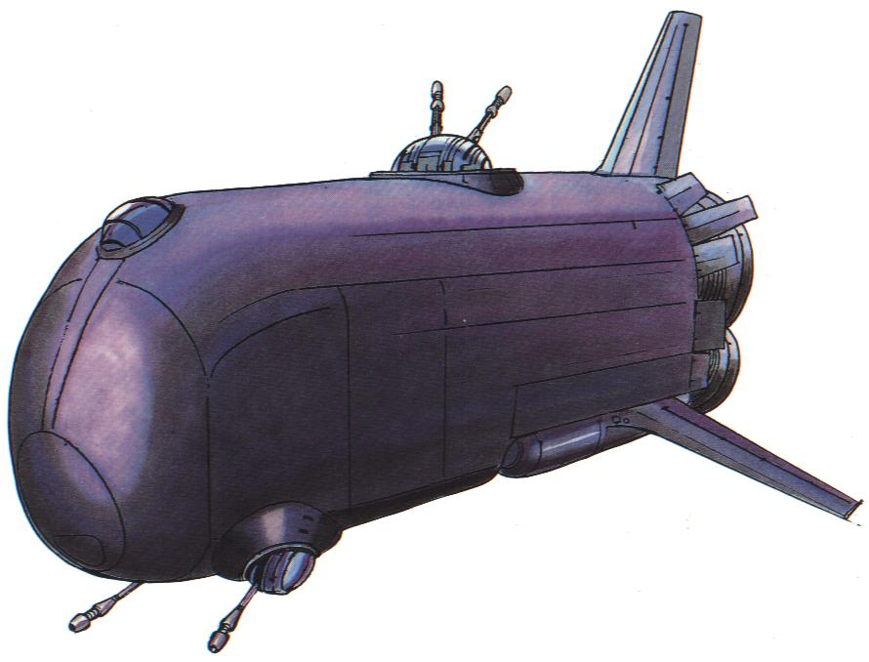

Freighters: In terms of its function and purpose, a freighter has a lot in common with a transport, but it is different enough that it belongs in a separate category. A freighter carries cargo, but its loads are typically small in volume and high in value and risk; the sort of merchandise that people do not feel comfortable about trusting to a lightly armed transport. To protect its cargo, a freighter generally is faster and better armed then transports; they typically have as many weapons as crew members.

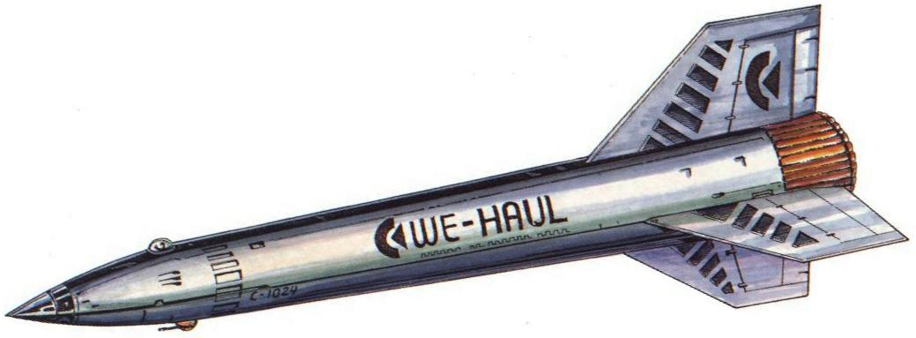

Transports: These ships are the beasts of burden. They come in a wide variety of shapes and sizes, but all have one fundamental thing in common; their purpose is to carry cargo. Transports are trans-atmospheric, they sacrifice speed, maneuverability, and armament for cargo space, and usually have a very small crew living in cramped quarters.

Ship Construction/C&C Pg.77
Designing a rocket ship is a lot like designing a character; there are attribute, hit points, weapons, and armor to be determined and selected. But unlike character attributes, ship attributes are not determined by using dice. Instead they are directly related to the tonnage of the ship. Although it is unlikely that characters will be designing or building ships, if more detailed information is desire, please read Ship Construction.

Ship Conversion/GM Addition
Although there are a nearly unlimited variety of rocket ship makes, models, styles, and sizes, you may not find one that suits your needs. Or perhaps you merely wish to customize a ship to your specifications. This is where ship conversion comes into play. Rocket ships may be modified to suit their owner’s desires, meet specific mission parameters, or for a special function. The ship's components may be “traded” for other components or for additional system survivability, a system’s ruggedness may be sacrificed for additional speed, or a trade can be made for a number of other options. The components that may be traded and a list of possible conversions are listed below.
Another conversion option s to refit the ship to carry fighters. This conversion option is usually restricted to larger ships, heavy cruisers (450 ton) and up. To accomplish this the ship exchanges five WS for one 10 ton fighter or ten WS for a 15-20 ton fighter. Although it may be theoretically possible for ships to be converted to carry larger vessels, a battler fitted to carry scout cruisers for example, this has not yet been done.
It is also possible to either permanently boost a ships speed or increase its ruggedness. To increase the ship’s speed one point, the ship’s systems HPs are reduce to make room for a bigger rocket motor; this is accomplished by reducing the components’ HPs to the level of a ship with 30% (round down) less tonnage. To increase the ship’s ruggedness (HPs), a smaller rocket motor is installed to allow the addition of redundant components, armor, and a larger fuel cell; this is accomplished by reducing speed one point and increasing the component’s HPs to the level of a ship with 15% (round down) more tonnage. The cost for such a conversion is equal to 1000cr per total HPs lost or gained.
NOTE: Tankers, some merchant ships, and specialty ships are exempt and may have conversion outside these limitations. All odd tonnage ships (15, 25, 35, and etc.) have a bonus ½ Weapon Space available.

Conversion Cost [1]
One Weapon Space
5 tons of extra cargo 5000
20 additional hull hit points 20,000
5 additional sensor/communication or controls hit points 5000
10 additional life support hit points 10,000
15 additional fuel points 15,000
15 additional engine hit points 15,000
Two ½ Weapon Space sized packages [2]
One ½ Weapon Space sized package and 2 tons of additional cargo [3]
Ten tons of Cargo
1 additional Weapon Space 10,000
20 additional hull hit points 20,000
5 additional sensor/communication or controls hit points 5000
10 additional life support hit points 10,000
15 additional fuel points 15,000
15 additional engine hit points 15,000
Five tons of Cargo
One ½ Weapon Space sized package [2]
NOTES: [1] – cost based on standard pricing for Venus, Earth and Mars (x1.5 Luna, x2 Mercury and The Belt, x3 Outer Worlds); [2] – 5000cr plus the cost of the package(s); [3] – 7000cr plus the cost of the package.

Operations/C&C Pg.79
The first thing you will need to know after you have bought a ship is how to keep it running, or if you bought a bargain basement model, how to get it into working condition. This means you will need to know about fuel, parts, repairs, spaceport fees, and supplies. See Services and Fees on Table 17c: Spaceships and Spaceship Accessories for most of the costs for the topics that follow.
Fuel: The stuff that makes your ship go. For ships with interplanetary travel capability, every five years they will need to replace their reactor’s atomic fuel rods.
Parts: In many cases, it is actually more convenient to replace a damaged ship system than to repair it. All of the sections of a ship are modular, and any or all of them can be replaced in five to ten hours, as opposed to an engineer spending a lot of time and effort, making various repair Skill Checks, to restore hit points in small amounts. Spaceship Accessories (Table 17c) gives the standard cost range for replacing the main systems. Making a replacement requires a trained engineer making a successful AVG repair Skill Check for the appropriate skill.
Repairs: Repairs are usually made only when money is scarce, the ship is far from port, or there is not too much damage to repair.
Spaceport Fees: Most spaceports have docking fees, the amount of these charges depend on the type of port and its location. Most ports charge for port pilots and towing as well.
Cargo and Supplies: As a rule, each person on a ship needs five pounds of food and water per day for survival. A part of your ship’s cargo space must be taken up by these items. Another consideration for cargo space is personal equipment and possessions; individual weapons, reloads, clothing, tools, and so forth. When calculating how much cargo you can haul around, remember to first deal with food, water, and personal possessions, since those are absolute necessities. And remember, you will also need to carry a supply of reloads for your ship’s weapons.

Space Ports/C&C Pg.80
A spaceport is a facility designed to handle takeoffs and landings of rocket ships. This is no mean feat, a rocket’s nuclear engine develops millions of pounds of thrust at temperatures that can make steel run like water. The launch bays of spaceports are constructed of special concrete that can withstand this titanic force. A large spaceport usually has several dozen launch bays, connected by a network of subways or monorails leading to hotels, repair shops, and shopping facilities. Every port also has a control tower in a central location, which pilots communicate with for clearance and landing permission.
Most planets and major asteroids have one or more spaceports, each one rated “A” through “C”.
Class A: Most Class A ports have facilities for building, repairing, replacing, and modifying all types of ships. There are usually hotels and restaurants within easy reach of the rocket field. There may be a rocket-building factory adjacent to the port.
Class B: A Class B spaceport is capable of replacing parts for most common types of ships. Parts are usually available (75%) or can be ordered and delivered within one to six days. The hotel and entertainment facilities are less accommodating than at a Class A facility and may be located miles from the actual port.
Class C: Class C ports have no repair or refitting facilities. They are usually open-field areas, lacking the features and sophistication of larger ports. There may be a few rough hangers or domes thrown up around the field, far enough back from the launch area to avoid being blasted by rocket exhaust. There often is not full-fledged control tower, only a shack containing a short-wave radio and radar gear.

Space Travel/C&C Pg.80
Getting from one planet to another in is not as time-consuming or as complicated as it was in the early days of space exploration. Instead of blasting off, reaching escape velocity, and then coating the rest of the way, which is how man took his first steps out into the solar system, modern ships have the ability to stay under power all the way from their takeoff point to their destination. The most important benefit of this advance in technology is that space travel is fast. Even a trip from the outermost edge of The Belt all the way to the other side is measured in days instead of weeks or months. Another good thing about travel in a ship that is under constant power is that courses are very easy to plot, a straight line from point A to point B is all it takes.
The Solar System Map: Interplanetary and inter-asteroid travel is plotted on the Solar System Map which is managed by the GM. The GM keeps track of the passage of time and the movement of the planets and asteroids. On the first of each month the GM moves the planets and asteroids one space along their orbital paths.
The Ruler: The “ruler” serves two purposes in the game. First, the ruler is used to determine the time lag, in minutes, for radio communication across space. Second, it is used to determine how long a trip will take, in days, based on how much fuel the crew is willing to burn. The more fuel burned (either 20, 30, or 40 points a day) the faster they arrive at their destination.

Running Out of Fuel/C&C Pg.81
Each time a ship makes a move or takes damage in its fuel section, it uses or loses fuel. When the ship’s fuel, or fuel HP, total is down to 0, it is out of fuel.
If the ship is being flown near the surface of a planet when it runs out of fuel, it falls like a rock. Landing an out-of-fuel ship requires a successful DIF or IMP pilot rocket Skill Check. A failure means the ship crashes.
If the ship is in deep space when it runs out of fuel, it will deviate from its original course by 15° to either side. This deviation comes from the jolt that the ship takes just as its engine dies. Then the ship will begin to drift in a straight line, moving at the 10-point-per-day rate. If its new line of movement brings it close (within one inch on the Solar System Map) to the sun or any of the inner planets, it will be captured by the planet’s gravity, and one to three days later it will spiral in and crash. If not, it will continue to drift until it leaves the confines of the solar system and become lost in space.

Moving on Planet/C&C Pg.81
Most ships are capable of moving inside a planet’s atmosphere as well as in space. For every point of speed a ship has, it can move at a top speed of 1000 miles per hour in the atmosphere. The ship burns points of fuel per hour equal to its speed points.

Salvage/GM Addition
In your travels you may come into possession of a ship and its contents that for whatever reason you do not wish to keep, nor do you wish to spend the time trying to sell the ship it on your own. This is when the option to sell the vessel as salvage comes into play. When a ship is salvaged, or captured, and does not have a Legal Claim for its Recovery and Return (some crews have been known to ignore the legal claims), the contents may be plundered and the ship may be sold as salvage. If you are not going to sell the ship as salvage, you may still plunder it, but you must board it to do so.
Plundering: Plundering a ship is taking from it what is needed (fuel, ammo, supplies, and etc.) or wanted (valuables, cargo, prisoners, and etc.) and then either leaving it, destroying it, or setting it adrift. If you wish to sell the plundered goods, the going rate is one-quarter its listed value without proof of ownership, if you can find a buyer.
Salvaging: Salvaging is legally claiming ownership of a ship via “salvage rights,” then towing it or calling for a tug to tow it back to a port to sell. You may still plunder the ship before salvaging it. If salvaged, the crew will get paid the value listed below for tonnage and operational components minus the percentage of damage, and for undamaged weapons and non-standard accessories. The total will be deposited into an account or accounts that the crew chooses in the bank or banks the crew chooses. If a tug was called, towing fees (100cr per hour) can be automatically subtracted from the total and deposited into the tug owner’s account. The table below is for the ship’s components, items with variable pricing, and items requiring special information. The going salvage rate for most working weapons and accessories is one-quarter their listed value.

Item Value [1] Item Value [1]
Components
Hull 1250 [2] Life Support 2000
Controls 1000 Nuclear Engine 7500
Sensor / Communications 1250
Weapons
Value [1]
Item Standard Light Heavy
Cyclorator [3] -- 500 750
Graser [3] -- 1125 1500
Mass Drivers Varies -- --
NOTES: [1] – value based on standard pricing for Venus, Earth and Mars (x1.5 Luna, x2 Mercury and The Belt, x3 Outer Worlds); [2] – per ton; [3] – these weapons are regarded as cruel, inhumane, or illegal (75% chance they will be confiscated without payment).

