  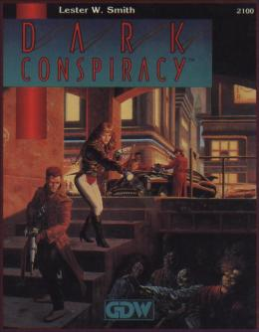  Dark Conspiracy  Player’s Supplement   | 1. | Character Generation
 | 2. | Careers
 | 3. | Skills
 | 4. | Empathy
 | 5. | Combat
 | 6. | Equipment
 | 7. | Dark Earth
 | 8. | Roleplaying

