  Player’s Handbook  Supplement  for the  World of Damiano  (Revision 1)  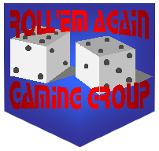 | 1. | Player Character  Ability Scores
 | 2. | Player Character  Races
 | 3. | Player Character Classes and Kits
 | 4. | Proficiencies,  Weapon & Non-Weapon
 | 5. | Money & Equipment
 | 6. | Magic
 | 7. | Combat
 | 8. | Role-Playing

